Chris Klassen – Melvin Loho – Jonathan Chu – Joel Mabbott

BCIT  3700 Willingdon Avenue

Windows assignment 3 UI Mockups

Table of Contents

Unicast Mode 2

Multicast Mode 3

Microphone Mode 4

# Unicast Mode

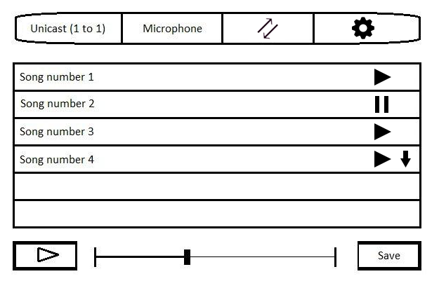

# Multicast Mode

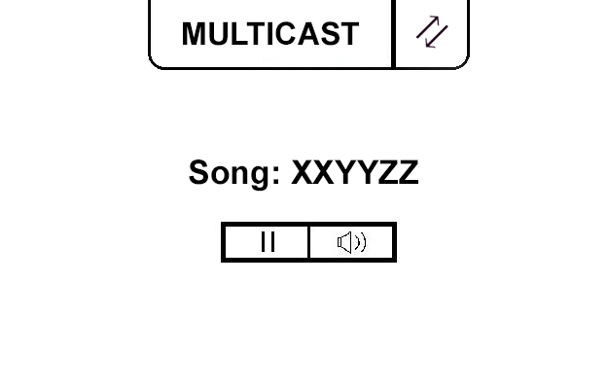

# Microphone Mode

